Screenshots of my final website

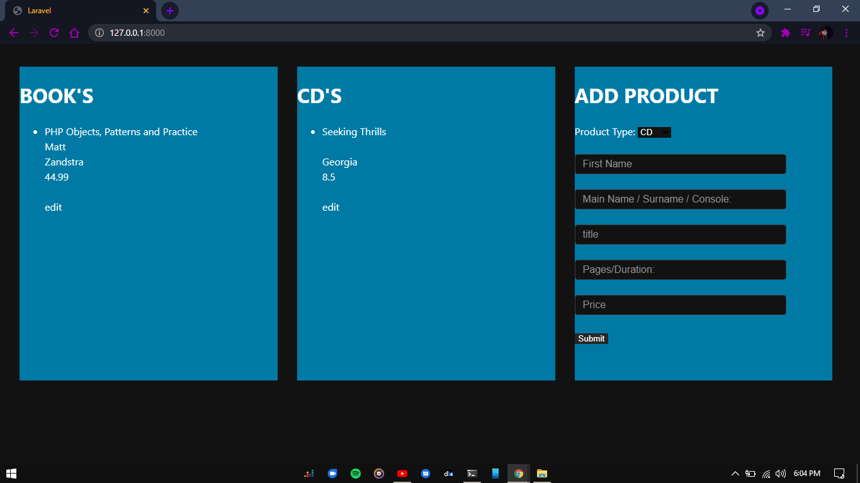

Fig 1: This is the user interface of my website

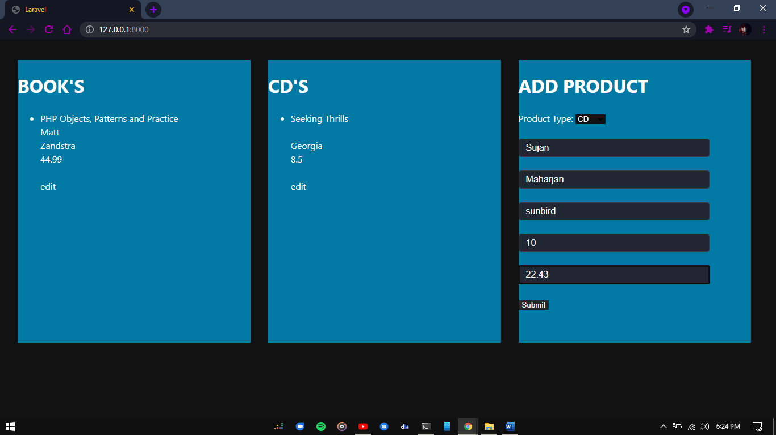

Fig 2: the right column there’s small form where you can add your choice of data and submit it.

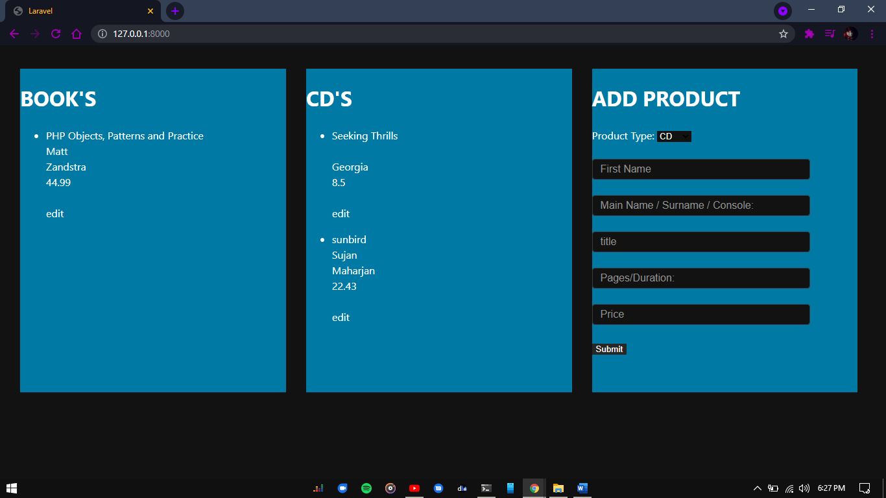

Fig 3: The data will be recorded

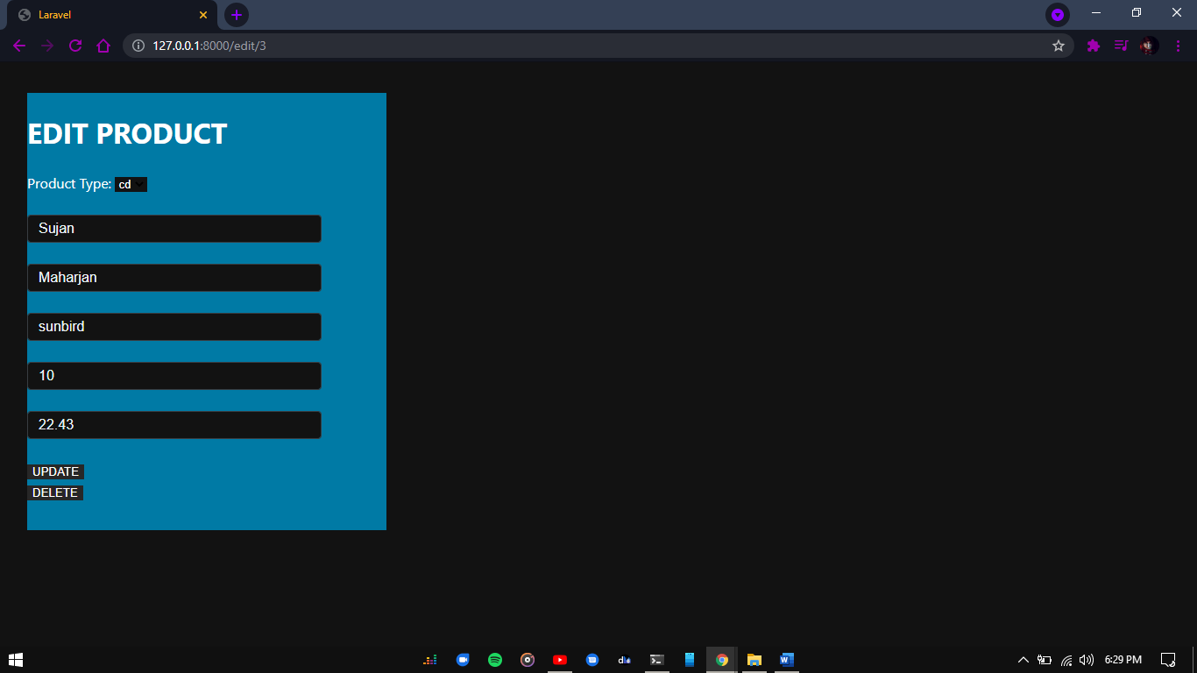

Fig 4: The data can be updated edited and can be deleted.

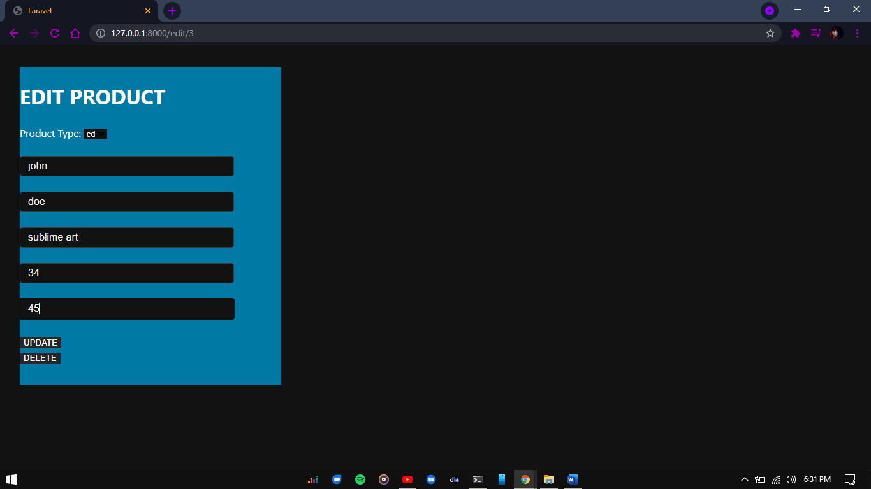

Fig 5: The data are being updated

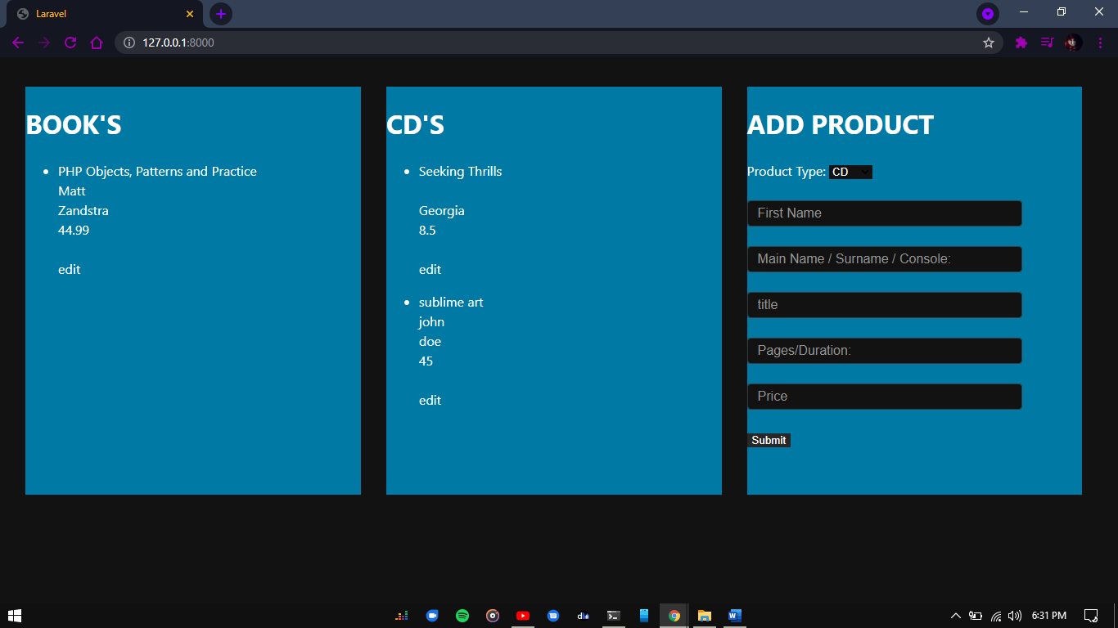

Fig 6: The Data has been updated

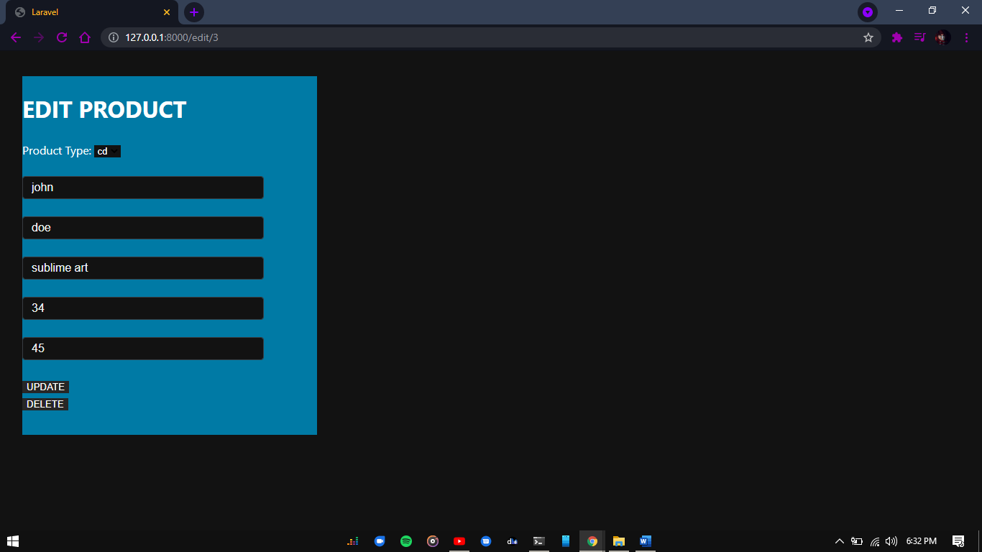 Fig 7: The data can be deleted as well.

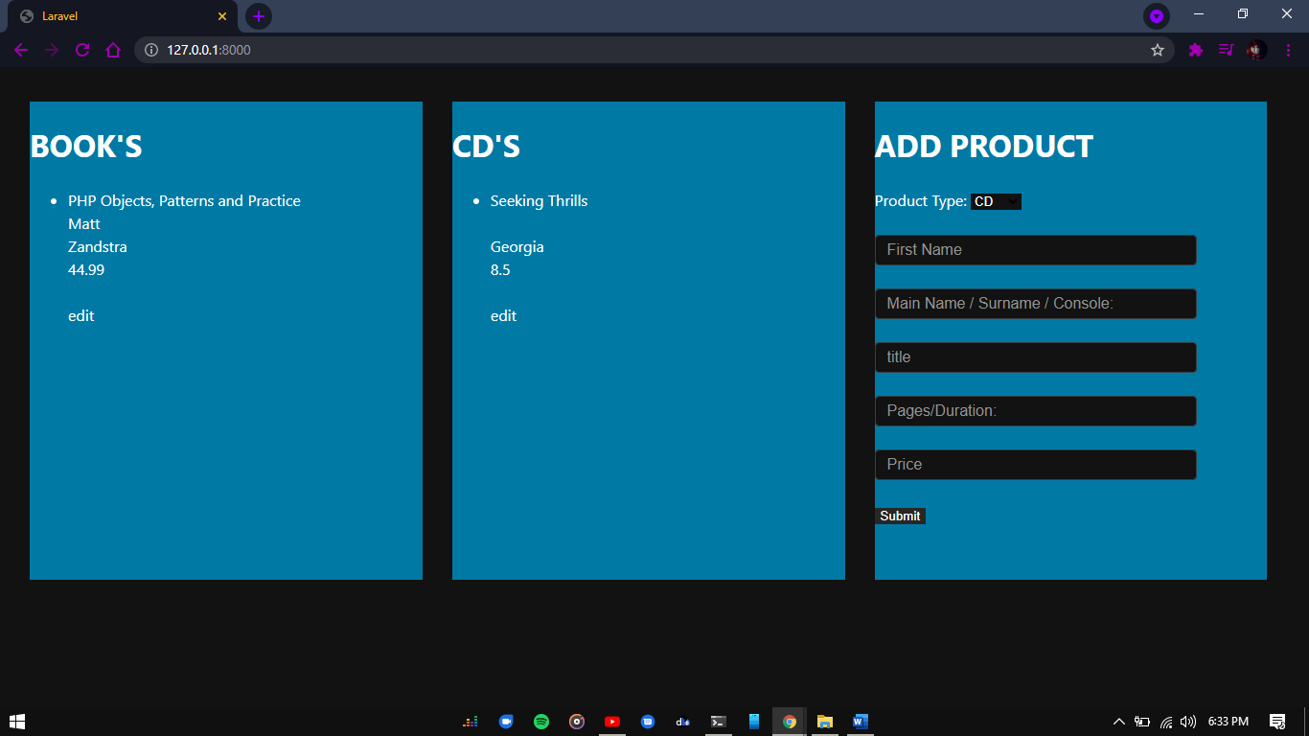

Fig 8: The data is deleted